**Final assignment**

1. **Kinematic analysis on acceleration level (with translational joints)**Translational (prismatic) joint implementation was the first step. The base code for adding the joint was the add_revolute.m. As we need 3 points on a line of translation to clearly determine that type of joint, the additional point s3 was added and the function add_prismatic.m was created. In the constraints.m the constraints of prismatic joints were added, according to two rules: 3 exact points on the line, no rotation between bodies. The next point was the adding of the Jacobian elements in constraints_dq.m for including the prismatic joints. And finally, for the calculation of acceleration, the function lhs_accel.m has been created, that returns us the left hand side of acceleration equation. This function is being used in the kinematic_analysis.m file for computing the Qpp parameter, which is the needed acceleration. Note: all the Jacobian matrix elements and y-vectors are took from Parviz E. Nikravesh book “Computer-aided analysis of mechanical systems”. By comparing the received data with the slider implementation by the usage of just simple joints and just a prismatic joint, the same results have been achieved (Figure 1).  
   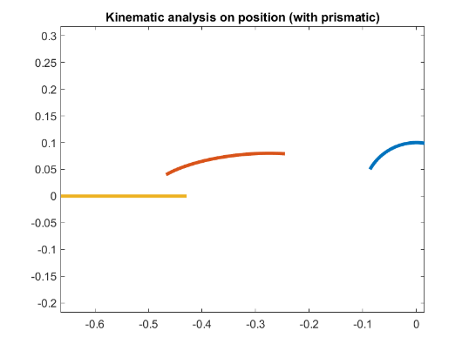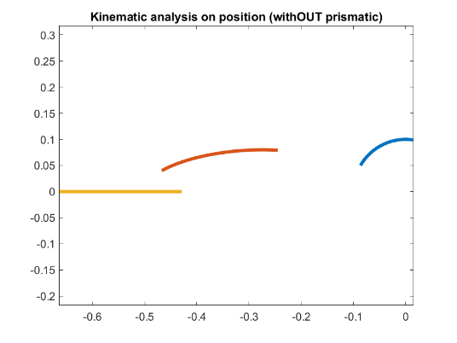

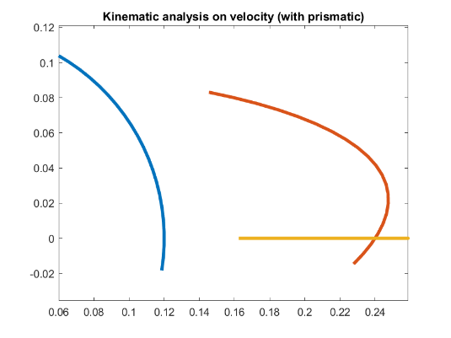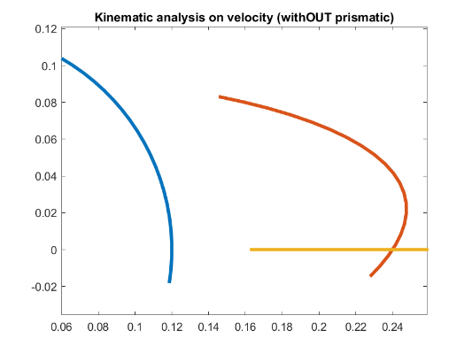

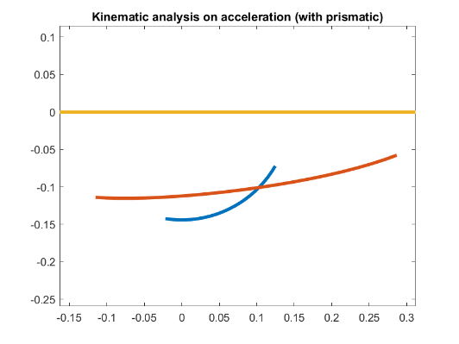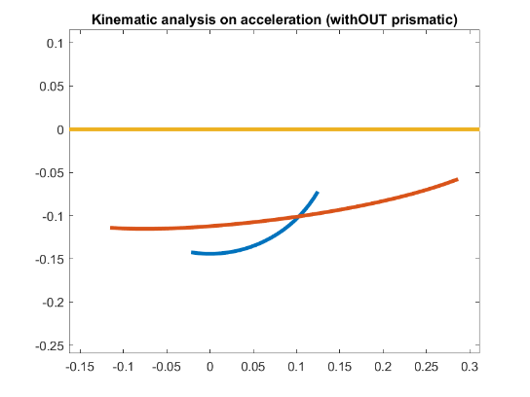

Figure 1 – graph comparison of different system implementation

The graphs are totally identical, and acceleration analysis has been done. By that we can conclude that the implementation of prismatic joint was successful.

1. **Dynamic solution of constrained multibody systems (internal ode45 instead of custom EC)**The main thing here is to adjust the acceleration.m function to fit into ode45 internal MATLAB solver. The velocity argument was deleted from the initial function and specific velocity (qd) condition was specified internally – for that, in case not to ruin the original acceleration.m function, the new function acceleration_for_ode45.m has been created. The results, as we can see (Figure 2) are not exact. Why is that so? The question isn’t answered by me yet.   
   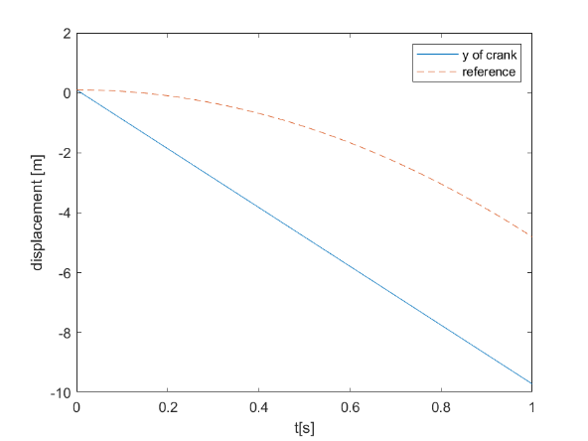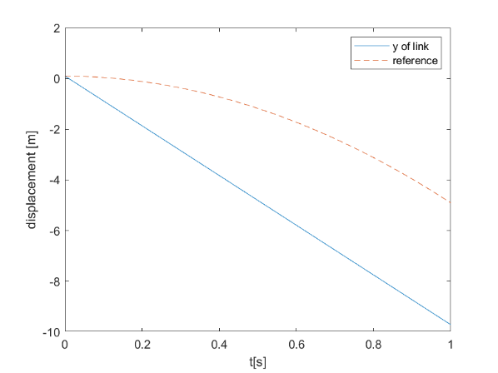

Figure 2 – ode45 (blue) and exact (red dashed) solution comparison

1. **Non-analyzed mechanism**In development…
2. **Cantilever beam model**

In development…